

[Date]

Lab Report on

Jacobi Iteration Method

Report No: 06

Course Code: CSE 224

Course Title: Numerical Analysis Lab

Submitted to:

Name: Adeeba Anis

Lecturer

Department of CSE

at Bangladesh University of Business and Technology.

Submitted by:

Name: Syeda Nowshin Ibnat

ID: 17183103020

Intake: 39

Section: 1

Program: B.Sc. in CSE

Date of Submission: 06.07.2020

**Experiment no:** 6

**Name of Experiment:** Find the value of x,y and z of the following system using Jacobi Iteration Method up to sixth iteration.

20x + y - 2z = 17

3x + 20y - z = -18

2x - 3y + 20z = 25

**Objective:** Use Jacobi Iteration method to numerically solve a nonlinear equation.

**Theory:** Jacobi iterative method is considered as an iterative algorithm which is used for determining the solutions for the system of linear equations in numerical [linear algebra](https://byjus.com/maths/linear-algebra/), which is diagonally dominant. In this method, an approximate value is filled in for each diagonal element. Until it converges, the process is iterated. This algorithm was first called the Jacobi transformation process of matrix diagonalization.

Let the n system of linear equations be Ax = b.

Here,

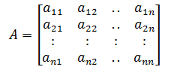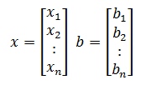

Let us decompose matrix A into a diagonal component D and remainder R such that A = D + R.

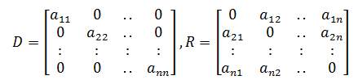

Iteratively the solution will obtain using the below equation.

x(k+1) = D-1(b – Rx(k))

Here,

xk = kth iteration or approximation of x

x(k+1) = Next iteration of xk or (k+1)th iteration of x

The formula for the element-based method is given as

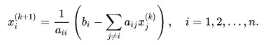

**Method:**

1. Obtain n, aj and bi values.
2. Set x0i = bi/aj for i = 1…n
3. Set key = 0
4. For i = 1, 2, …n

Set sum = bi

For j = 1, 2…n(j≠i)

Set sum = sum – aj x0i

Repeat j

Set xi = sum/aj

If key = 0 then

If || > error then

Set key = 1

Repeat i

1. If key = 1 then

Set xoi = xi

go to step 3

1. Write results

**C Program:**

#include<stdio.h>

#include<conio.h>

#include<math.h>

float fx(float y,float z) {

float x1; x1=(17-y+2*z)/20;

return x1; }

float fy(float x,float z) {

float y1;

y1=(-18-3*x+z)/20;

return y1; }

float fz(float x,float y) {

float z1;

z1=(25-2*x+3*y)/20;

return z1; }

int main() {

int i,j,n;

float a1,b1,c1;

float a,b,c;

printf("Enter the no. of Iteration : ");

scanf("%d",&n);

printf("Enter The initial value : ");

scanf("%f %f %f",&a,&b,&c);

for(i=1;i<n;i++) {

for(j=0;j<n;j++) {

a1=fx(b,c);

b1=fy(a,c);

c1=fz(a,b);

a=a1;

b=b1;

c=c1;

} }

printf("\na1 = %f\na2 = %f\na3 = %f",a1,b1,c1);

getch();

return 0; }

**Output:**

